DHCP Server Connection:

First take router PT and two router PT switch.

Server with 2 PCs on one side  
and three pcs on other side.

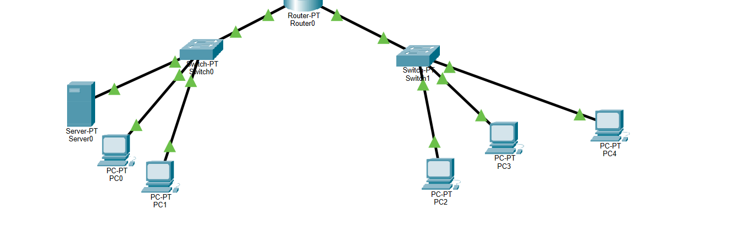

Now you give address to server pt like 172.168.1.2 and default gateway.

Then, create two pools with 172.168.10.1, 192.168.10.1.